

**Data Collection and Preprocessing Phase**

|  |  |
| --- | --- |
| Date | 9 July 2024 |
| Team ID | team-739821 |
| Project Title | Precise Coffee Quality Prediction |
| Maximum Marks | 6 Marks |

**Data Exploration and Preprocessing Template**

Dataset variables will be statistically analyzed to identify patterns and outliers, with python employed for preprocessing tasks like normalization and feature engineering .Identifies data sources, assesses quality issues like missing values and duplicates, and implements resolution plans to ensure accurate and reliable analysis.

|  |  |
| --- | --- |
| **Section** | **Description** |
| Data Overview | Dimensions:  207 rows x 19 columns Descriptive Statistics: |
| Univariate Analysis |  |

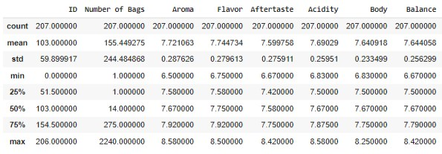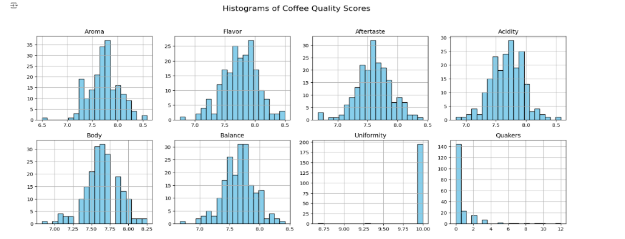



|  |  |
| --- | --- |
| Bivariate Analysis |  |
| Multivariate Analysis |  |

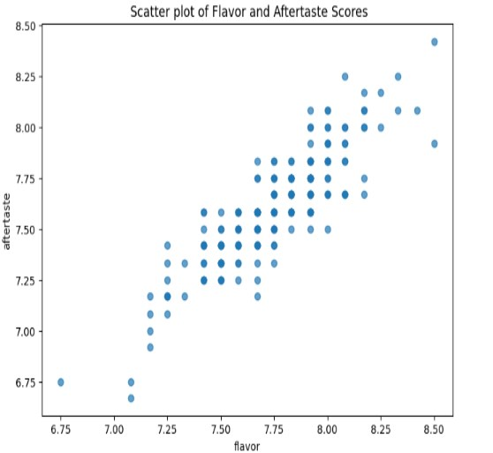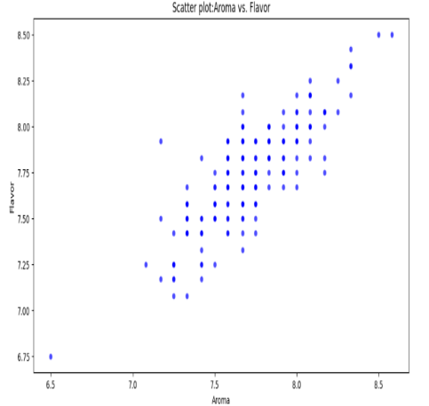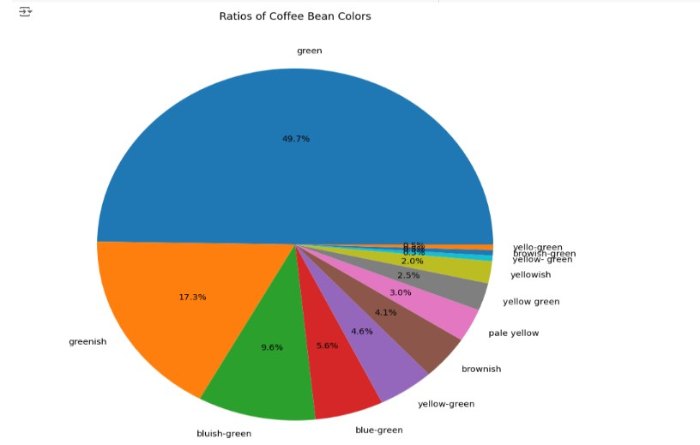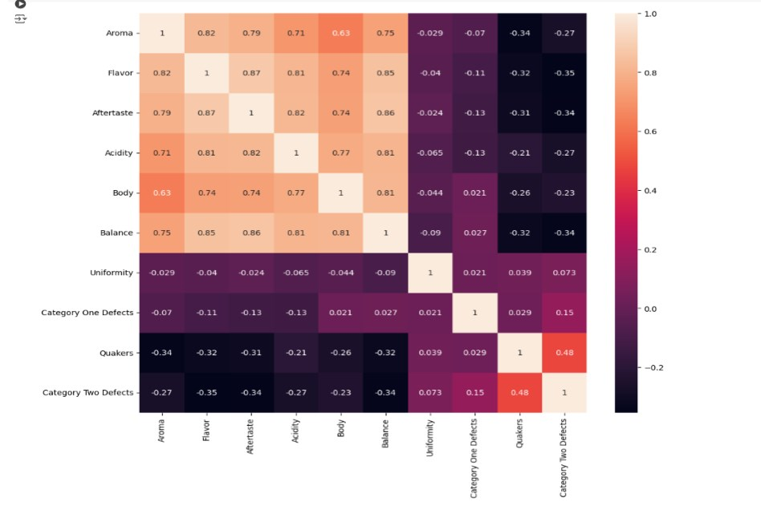



|  |  |
| --- | --- |
| Outliers and Anomalies |  |
| **Data Preprocessing Code Screenshots** | |
| Loading Data |  |
| Handling Missing Data |  |

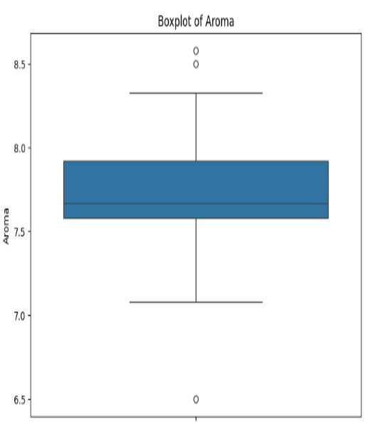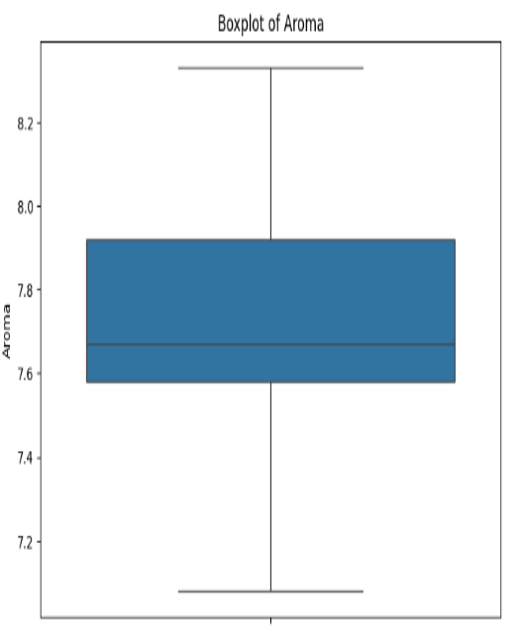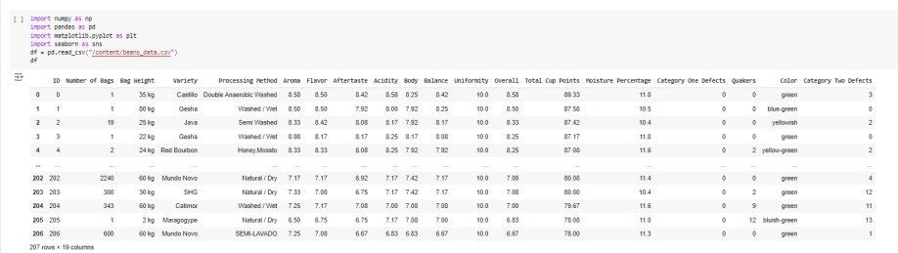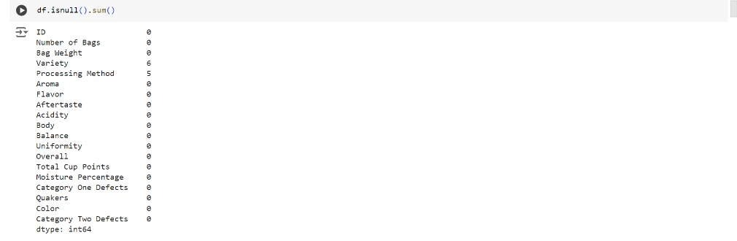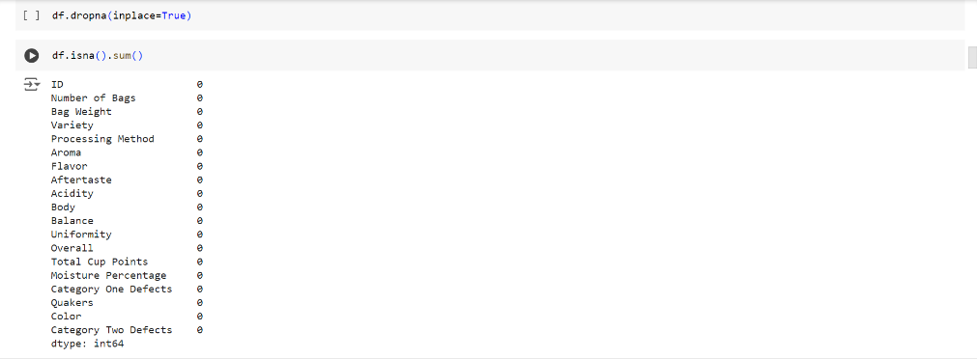



|  |  |
| --- | --- |
| Data Transformation |  |
| Feature Engineering |  |
| Save Processed Data |  |

